Software Requirements Specification (SRS) for the Language Learning Chatbot Platform

Supervised by:
Dr. Mohamed Shalaby

Prepared by:
1) Jana Tamer 2023/05507
2) Norhan Khaled 2023/04880
3) Mohamed Hesham 2023/00428
4) Veronia Sameh 2023/00592
5) Mohanad Ezzat 2023/08326

GitHub: https://github.com/mohamedelziat50/language-learning-chatbot-MIU

Contents
1.Preface: 4
2.Introduction: 4
2.1 Purpose: 4
2.2 Scope: 4
2.3 System Overview: 4
3. Similar Systems: 5
3.1 Duolingo 5
3.2 Babel 5
3.3 ChatGPT 5
3.4 Grammarly 5
4. Glossary: 6
5. Functional User Requirements: 7
5.1 User Registration & Authentication: 7
5.2 Admin Dashboard: 7
5.3 Interactive Language Practice (Chatbot) 7
5.4 Progress Tracking: 7
5.5 Topics: 8
5.6 Quiz Generation and Management: 8
6. Functional System Requirements: 8
6.1 User Registration & Authentication: 8
6.2 Admin Dashboard: 8
6.3 Interactive Language Practice (Chatbot): 9
6.4 Progress Tracking: 9
6.5 Topics: 9
6.6 Quiz Generation and Management: 9
7. Non-Functional Requirements: 10
7.1 Performance Requirements 10
7.2 Security Requirements 10
7.3 Usability Requirements 10
7.4 Reliability Requirements 10
7.5 Scalability Requirements 11
7.6 Maintainability Requirements 11
8. Prototype of All Forms / Pages: 11
8.1 Login Page: 11
8.2 Chatbot Page: 11
8.3 Progress Page: 11
8.4 Admin Dashboard: 11
8.5 Student Dashboard: 11
8.6 Student Profile: 12
8.7 Language Selection Page: 12
8.8 Topics Page: 12
8.9 Lessons Page: 12
9.0 Dictionary: 12
9.1 Quiz Page: 12
9. Scenarios: 12
9.1 Scenario 1: Student 12
9.2 Scenario 2: Tutor 12
9.3 Scenario 2: Admin 12
10. Use Cases: 13
11. Form-Based Specification: 13
11.1 Function Name: User Login 13
11.2 Function Name: Chatbot Interaction 14
12. Tabular Specification 15
12.1 Admin Login 15
12.2 Chatbot Interaction 16
13 References 16

1.Preface:
This SRS defines the requirements for the Language Learning Chatbot Platform, an interactive system designed to enhance language acquisition through conversational practice, real-time feedback, and gamified learning. The platform aims to provide accessible and enjoyable language practice for students globally.

2.Introduction:

2.1 Purpose:
To detail the functional and non-functional requirements necessary for the successful development and deployment of the Language Learning Chatbot Platform.

2.2 Scope:
The platform provides language learners with an AI-powered environment where they can:
- Practice target languages via chatbot interactions.
- Participate in discussion forums for collaborative learning.
- Track their progress through analytics and achievements.
- Engage with a gamified experience that rewards consistent learning.

2.3 System Overview:
The platform integrates:
- AI Chatbot for natural language conversation practice
- Discussion forums for community learning
- Progress tracking dashboards
- Gamification for motivation and engagement
- Role-based access (Student, Tutor, Admin)

3. Similar Systems:

3.1 Duolingo
Duolingo is a popular language learning platform that allows users to practice different languages through gamified lessons, vocabulary exercises, and quizzes. It provides limited
chatbot conversations for selected languages to improve speaking and writing.
Similarity: Uses gamification and conversation-based learning like our system.
Difference: Our platform offers real-time feedback, tutor interaction, and discussion forums, which Duolingo lacks.

3.2 Babel
Babbel focuses on structured language courses with real-life dialogues and grammar explanations. It helps users practice speaking and listening through guided lessons.
Similarity: Supports conversational learning and structured lessons.
Difference: Babbel does not include AI-driven chatbots or adaptive feedback; our system provides instant grammar and vocabulary correction.

3.3 ChatGPT
ChatGPT can simulate language conversations and provide explanations, helping users improve writing and speaking in various languages.
Similarity: Uses AI and NLP for natural conversation and language correction.
Difference: Our system focuses specifically on language education, integrates progress tracking, user roles (student/tutor/admin), and gamification

3.4 Grammarly
Grammarly helps users improve their writing by detecting grammar, spelling, and style errors in real-time.
Similarity: Provides instant feedback and correction.
Difference: Grammarly focuses on writing improvement only, while our system supports full conversational practice, lessons, and gamified learning.

4. Glossary:

Term | Definition
TCD | Target Conversation Difficulty
NLP | Natural Language Processing
Gamification | Application of game design elements to non-game contexts.
SR | System Response
Target Language | The language the student is attempting to learn/practice.
SRS | Software Requirements Specification
Admin | System Administrator.
Student | The learner who practices languages using chatbots, topics and forums.
Tutor | The mentor who provides guidance and monitors’ progress.
Chatbot | An AI program designed to simulate conversation with learners.

5. Functional User Requirements:

5.1 User Registration & Authentication:
The system shall provide a secure and user-friendly registration and login process to ensure the protection of user data and privacy. Users shall have the flexibility to create an account using their email credentials or continue registration through Google Authentication for a faster and more seamless experience. Administrators shall be granted secure login access to the Admin Dashboard to manage and monitor system activities. In addition, the platform shall include an email-based password recovery feature, allowing users to easily reset their credentials when necessary.

5.2 Admin Dashboard:
The system shall provide administrators with a secure and intuitive dashboard for managing and monitoring platform activities. The Admin Dashboard shall display key statistics, including the number of active users, total chat volume, and trending discussion topics, offering valuable insights into user engagement. Additionally, administrators shall have the ability to manage user accounts, oversee chatbot interactions, and moderate forum discussions to maintain a safe and effective learning environment.

5.3 Interactive Language Practice (Chatbot)
The system shall enable users to initiate chat sessions with the AI-powered chatbot to practice and enhance their language skills. Users shall be able to select their preferred language and topic before starting a session, allowing for personalized and focused communication. The chatbot shall provide real-time interaction, promoting an engaging and immersive language learning experience.

Progress Tracking:
The system shall allow users to monitor their learning progress through detailed performance metrics such as conversation count, accuracy, and overall improvement. Personalized dashboards display visual statistics that reflect each user’s development over time, enabling them to track their achievements and identify areas for further practice and growth.

5.5 Topics:
The system shall allow users to explore and learn the fundamental concepts of each available language through structured content. For every selected language, users shall be able to access a collection of categorized topics that cover essential lessons and practical applications, supporting a comprehensive and engaging learning experience.

5.6 Quiz Generation and Management:
The system shall allow users to take AI-generated quizzes tailored to their selected language, reinforcing the concepts they have learned through interactive practice. Users shall be able to specify the quiz duration and difficulty level to match their learning preferences. Upon completion, the platform shall automatically evaluate the responses and display the user’s quiz results, providing immediate feedback to support continuous improvement.

6. Functional System Requirements:

6.1 User Registration & Authentication:
The system shall validate user credentials and securely store them using password hashing to ensure data protection and privacy. It shall manage user sessions effectively, maintaining authentication states throughout the user’s interaction with the platform. The system shall integrate Google Authentication to provide a seamless social login option. Administrative credentials shall be authenticated separately, and verified administrators shall be redirected to the Admin Dashboard upon successful login. Additionally, the system shall support a password recovery mechanism by sending reset links to the registered email address, ensuring secure and convenient account management.

6.2 Admin Dashboard:
The system shall generate and display comprehensive user statistics and activity summaries within the Admin Dashboard, providing real-time insights into platform performance and engagement. It shall allow administrators to perform full CRUD (Create, Read, Update, Delete) operations on user accounts to ensure accurate and up-to-date user management. Additionally, the system shall include moderation tools that enable administrators to review, manage, and control forum content, maintaining a safe and organized learning environment.

6.3 Interactive Language Practice (Chatbot):
The system shall store and retrieve conversation history for each user session to ensure personalized and continuous learning. The AI-powered chatbot shall process user inputs intelligently and respond according to the selected language and topic, maintaining contextual accuracy throughout the conversation. Additionally, the chatbot shall provide automatic feedback and corrections where appropriate, helping users improve their grammar, vocabulary, and overall communication skills.

6.4 Progress Tracking:
The system shall monitor and analyze user performance by tracking key learning metrics such as accuracy, frequency of interaction, and overall improvement. It shall store this data securely and present it through visual analytics on the user’s dashboard, enabling learners to assess their progress over time. These insights shall help users identify strengths and areas that require further practice.

6.5 Topics:
The system shall display a comprehensive list of topics for each available language, allowing users to explore lessons aligned with their learning goals. Each topic shall include structured lessons that support grammar and vocabulary development, while dictionary entries shall be linked across all supported languages to enhance contextual understanding. Furthermore, all topics, lessons, and dictionary content shall be dynamically retrieved from the database to ensure consistency and scalability.

6.6 Quiz Generation and Management:
The AI engine shall dynamically generate quiz questions based on the selected language and difficulty level, providing users with personalized assessments. The system shall automatically evaluate user responses, calculate results, and display final grades upon completion. Additionally, it shall store quiz history and previous scores, allowing users to review their performance and track their learning progress over time.

7. Non-Functional Requirements:

7.1 Performance Requirements
The system shall be capable of handling multiple concurrent users efficiently without causing noticeable delays or performance degradation. The average response time for chatbot interactions shall remain minimal and shall not exceed a few seconds under normal operating conditions to ensure smooth and responsive communication. Additionally, the system shall maintain optimized database performance, providing fast and reliable access for all CRUD operations to support real-time functionality across the platform.

Security Requirements
The system shall ensure data confidentiality, integrity, and secure access across all components. All user passwords shall be stored using strong hashing algorithms such as bcrypt to prevent unauthorized data exposure. Role-based access control (RBAC) shall be implemented to restrict sensitive operations to authorized users only. All communication between the client and server shall be secured using HTTPS/SSL encryption to protect data during transmission. The system shall provide secure authentication mechanisms through both email/password login and Google Sign-In integration. Additionally, robust session management shall be enforced to prevent unauthorized access after logout or session timeout.

7.3 Usability Requirements
The system shall feature a simple, intuitive, and mobile-responsive user interface to ensure ease of use across all devices. Navigation shall remain consistent across all pages, including the dashboard, chatbot, quiz, and profile sections, to provide a seamless user experience. The system shall deliver real-time feedback and guidance messages to assist users in performing tasks efficiently. Additionally, tutorials and tooltips shall be available to help users understand system functionalities and enhance overall usability.

7.4 Reliability Requirements
The system shall ensure automatic saving of all user progress data, including lessons, quizzes, and other learning activities, to prevent any potential data loss and maintain consistent reliability in user experience.

7.5 Scalability Requirements
The system shall be designed to support the seamless addition of new languages, topics, and lessons without requiring major architectural changes. It shall also allow for future expansion of user roles, such as moderators or guest tutors, to accommodate evolving platform needs. Additionally, the database structure shall efficiently handle increasing data volumes generated by thousands of users while maintaining optimal performance.

7.6 Maintainability Requirements
The software shall adhere to the Model-View-Controller (MVC) architecture to ensure a clear separation of concerns and facilitate efficient maintenance. All codes shall be modular, readable, and well-documented, enabling easier updates, debugging, and scalability. Furthermore, version control shall be managed through GitHub to support effective collaboration and change tracking throughout the development lifecycle.

8. Prototype of All Forms / Pages:

8.1 Login Page:
User authentication with role-based redirection.

8.2 Chatbot Page:
Interactive chat window with text input and bot responses.

8.3 Progress Page:
Tables showing completed lessons and badges.

8.4 Admin Dashboard:
User management and analytics overview.

8.5 Student Dashboard:
Main landing home page

8.6 Student Profile:
Page includes everything related to the student like languages enrolled in, progress of each language progress and daily streak.

8.7 Language Selection Page:
Page includes available languages to start learning.

8.8 Topics Page:
Includes topics related to the targeted language.

8.9 Lessons Page:
Include 5 Lessons of chosen topics with Grammar and Vocabulary.

9.0 Dictionary:
Dictionary of words in all available languages.

9.1 Quiz Page:
Allow users to take AI-generated quizzes by selecting the desired duration and difficulty level.

9. Scenarios:

9.1 Scenario 1: Student
Actor: Ahmed (Student)
Goal: Practice and improve his French conversation skills using LinguaBot
Flow of Events:
- Ahmed logs into LinguaBot using his student credentials.
- He is redirected to the Student Dashboard, which displays his progress, badges, and daily streak.
- Ahmed clicks on “Start Chat Practice” and selects the topic French – Everyday Conversations.
- The chatbot greets him in French and starts a conversation about ordering food at a café.
- As Ahmed types his responses, the chatbot provides:
  - Grammar corrections
  - Vocabulary suggestions
  - Sentence rephrasing tips
- His progress analytics update automatically, showing improvement in vocabulary and sentence accuracy.

9.2 Scenario 2: Tutor
Actor: Sara (Tutor)
Goal: Monitor student progress and provide learning support through the discussion forum
Flow of Events:
- Sara logs into her Tutor Dashboard.
- She reviews student analytics and notices that Ahmed struggles with past tense conjugations.
- Sara navigates to the Discussion Forum and creates a new topic titled “Common Mistakes in French Past Tense.”
- She uploads short examples, provides explanations, and replies to student comments.
- After a few days, she checks the Student Progress section to see which students interacted with her post and whether their scores improved.
- Sara marks this discussion as a completed activity and prepares new practice content for next week.

9.3 Scenario 2: Admin
Actor: Omar (Administrator)
Goal: Maintain system performance, manage users, and update chatbot learning content
Flow of Events:
- Omar logs into the Admin Dashboard using secure authentication.
- The dashboard displays system analytics, including:
  - Number of active users
  - Total chatbot sessions
  - Server uptime and performance statistics
- Omar updates the chatbot’s language database with new vocabulary and expressions for multiple languages.
- He reviews inactive or duplicate accounts and removes them to maintain database efficiency.
- Omar opens the Analytics Module to identify trends in user engagement and learning topics.
- Finally, he exports a weekly system report to share with the development team for performance evaluation and improvement planning.

10. Use Cases:
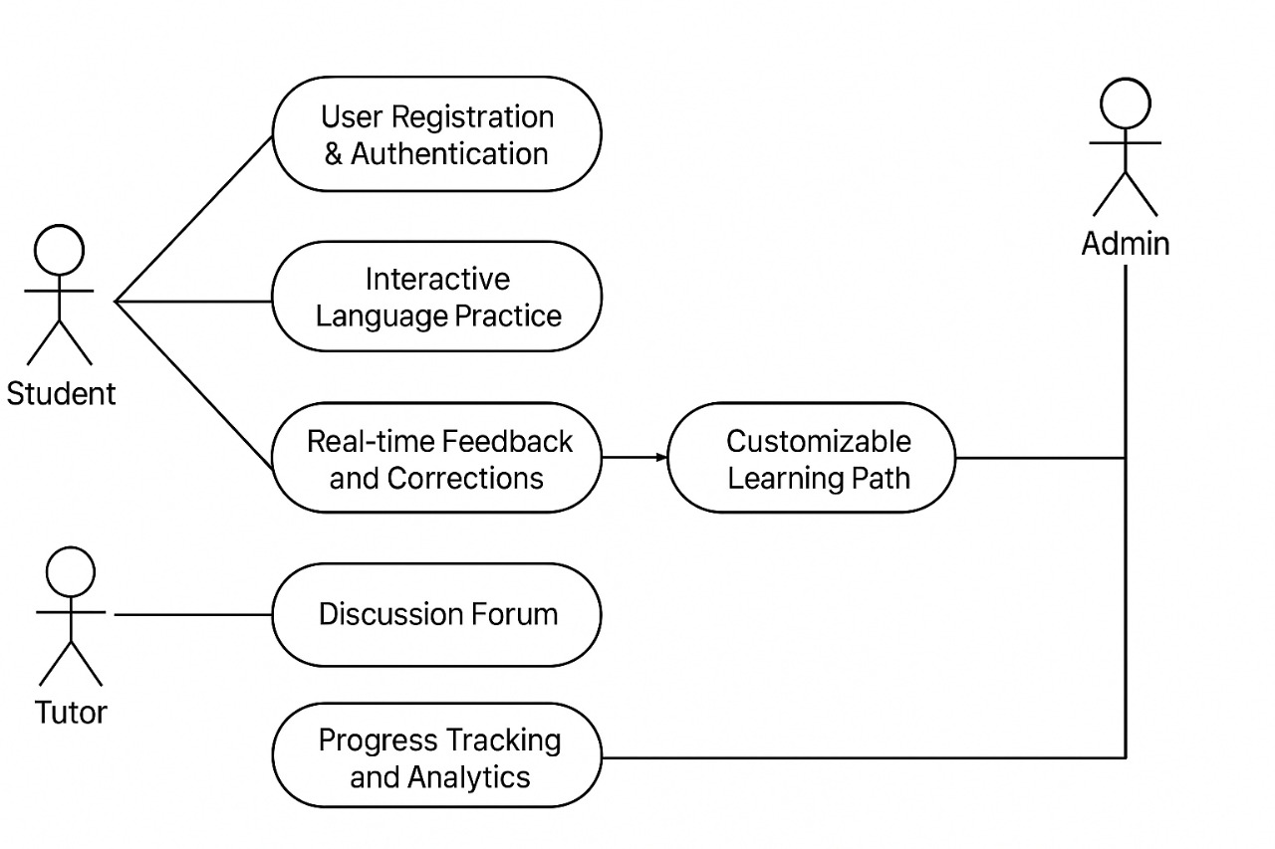

11. Form-Based Specification:

11.1 Function Name: User Login

Attribute | Description
Function Name | User Login
Description | Allows users (students, tutors, and admins) to log in securely using email and password or Google Authentication.
Inputs | Email, Password, Google Account.
Outputs | Successful login redirects user to the appropriate dashboard (Student, Tutor, or Admin); unsuccessful login shows an error message.
Preconditions | The user must already be registered in the system.
Postconditions | A session is created and stored for the logged-in user.
Side Effects | None
Source | User Registration & Authentication requirement in Section 3.1

11.2 Function Name: Chatbot Interaction

Attribute | Description
Function Name | Chatbot Conversation
Description | Allows users to communicate with the AI chatbot for language practice and receive feedback.
Inputs | User message, selected topic, and language.
Outputs | Chatbot response message
Preconditions | User must be logged in and have selected a language or topic.
Postconditions | Conversation history is temporarily stored for progress tracking.
Side Effects | None
Source | Interactive Language Practice requirement in Section 3.3

12. Tabular Specification

12.1 Admin Login
Condition | Action
Admin enters correct username and password | System verifies credentials and redirects admin to the Admin Dashboard.
Admin enters incorrect username or password | System displays “Invalid credentials” messages and denies access.
Admin leaves any required field blank | System displays validation error prompting to fill all fields.
Admin attempts to access the dashboard without logging in | System redirects the admin to the login page.
Database connection fails during login | System displays an error message indicating a server issue.

12.2 Chatbot Interaction
Condition | Action
User selects a language and starts a chat session | System initializes a chatbot session for the selected language.
User sends a valid message in the target language | Chatbot processes input and generates a relevant response using NLP.
User sends an invalid or unrelated message | Chatbot prompts the user to rephrase or give an example sentence.
User ends the chat session | System saves conversation history and closes the session.
Connection to chatbot server fails | System displays an error: “Chatbot unavailable. Please try again later.”

13 Future Enhancements
- Enhanced Content and Language Scalability
Seamless Integration of New Content: Continue to design the system to support the seamless addition of new languages, topics, and lessons without requiring major architectural changes, as mandated by current requirements.
- Adaptive AI and Personalized Learning Paths
Proactive Feedback: Extend the AI-powered feedback to create truly adaptive learning paths for students, automatically suggesting specific lessons, quizzes, or chat topics based on identified weaknesses in their progress metrics
14 Conclusion

The Software Requirements Specification (SRS) successfully defines the needs for the Language Learning Chatbot Platform, an interactive system designed to make language acquisition engaging and effective.
The platform's core is the AI-powered Chatbot which offers real-time conversational practice, grammar, and vocabulary correction, a key advantage over similar systems like Babbel and Duolingo. Beyond the chatbot, the system includes essential components for comprehensive learning.

15 References
The following references were used in preparing this Software Requirements Specification (SRS) document:
- Duolingo – Official website: https://www.duolingo.com
- Babbel – Official website: https://www.babbel.com
- Grammarly – Official website: https://www.grammarly.com
- OpenAI ChatGPT – Official website: https://chat.openai.com

